Task on terraform-01
1). Install Terraform on your PC
downloaded terraform from the browser and installed in the pc in D drive:
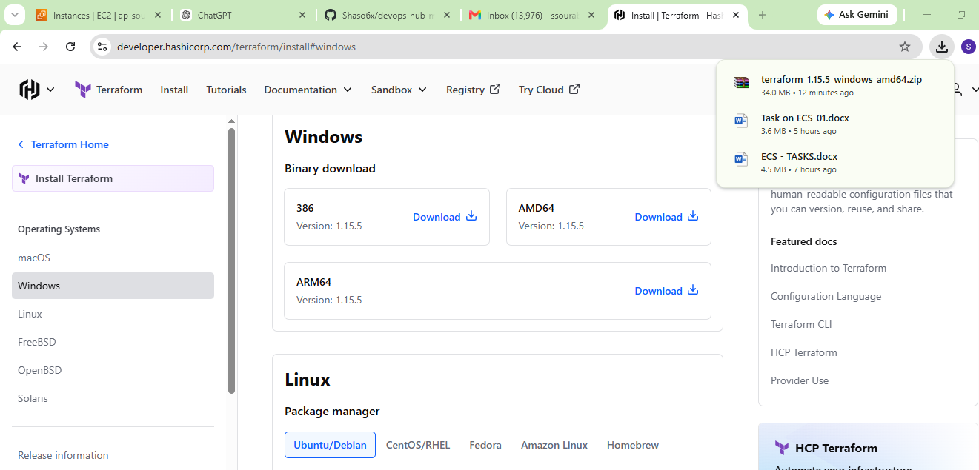
click on windows button and find environment variables and then click on system variables you will see path option click on that and then click edit
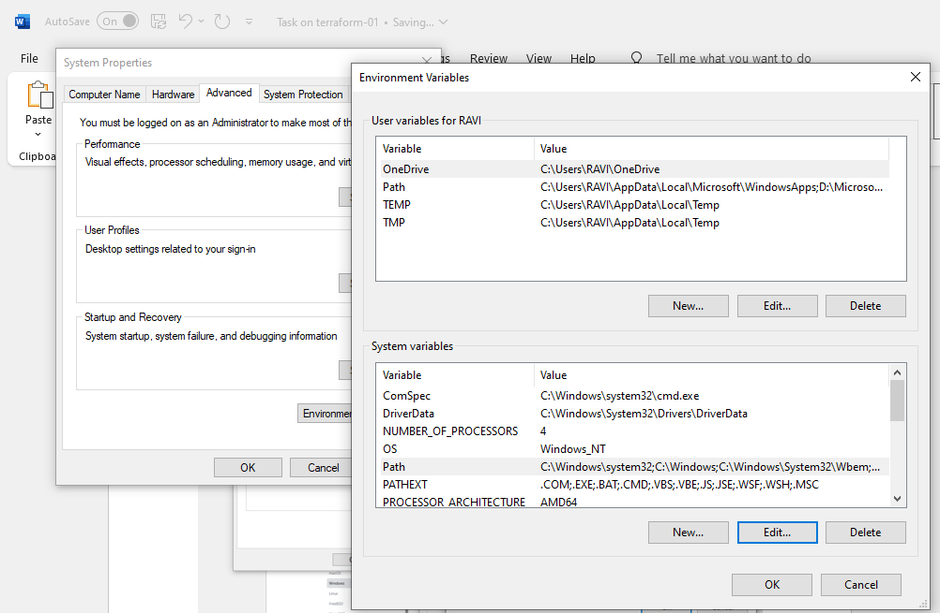
Add the file from the D drive and select the terraform folder:
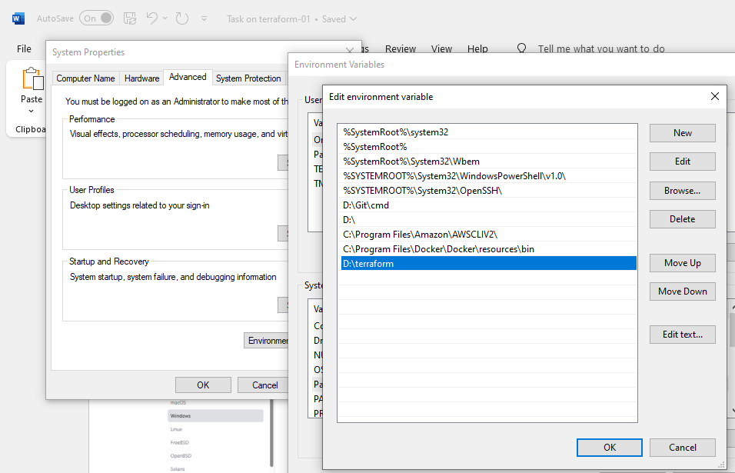
2). Execute all the templates shown in video.
Create a new folder in the desktop with terraform name and then open Visualstudio:
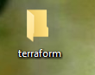
installed the terraform from the visual studio extensions.
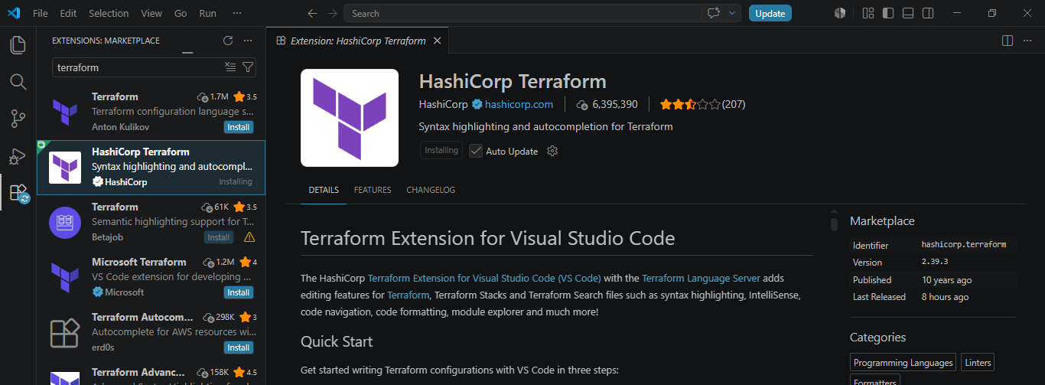
click on new folder main.tf name and then select the desktop terraform file:
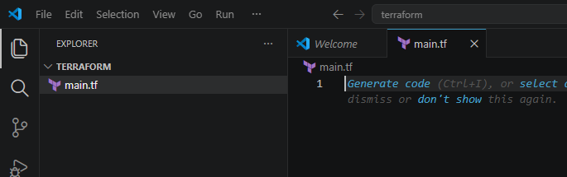
Paste the same script from the documents shared script in slack :
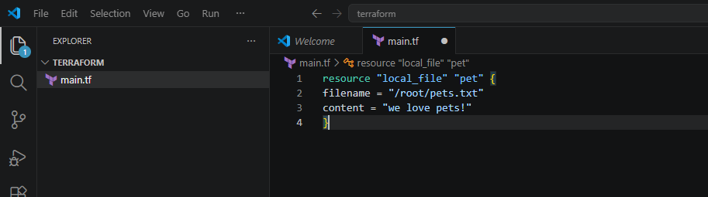
Type terraform -verison
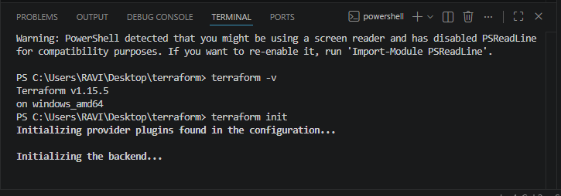
Type terraform plan:
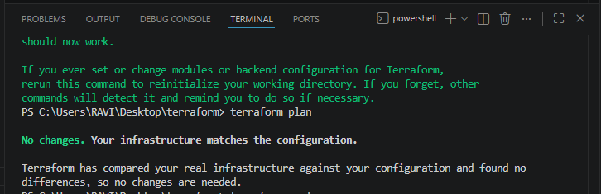
type terraform apply:
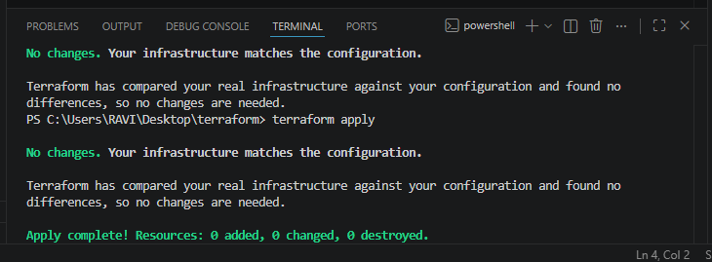
3). Note down below points, Terraform Init Terraform Plan Terraform Apply Terraform Provider.
1.Terraform Init terraform init
Purpose:
● Initializes Terraform working directory
● Downloads required provider plugins
● Sets up backend configuration (if any) What happens internally:
● Creates .terraform/ folder
● Downloads provider (AWS, local, etc.)
● Reads configuration files
2.Terraform Plan terraform plan Purpose:
● Shows execution plan before applying changes
What it does:
● Compares current state vs desired state
● Shows:
○ What will be created (+)
○ What will be changed (~)
○ What will be destroyed (-)
Use:
Safe preview step before making real changes
3.Terraform Apply
or
terraform apply -auto-approve
Purpose:
● Executes the changes defined in configuration
What it does:
● Creates real infrastructure (EC2, files, VPC, etc.)
● Updates Terraform state file (terraform.tfstate)
4.Terraform Provider
Definition:
A provider is a plugin that allows Terraform to interact with APIs
Example:
provider "aws" {
region = "ap-south-1"
}
What it does:
● Connects Terraform to cloud platforms
Examples:
○ AWS Provider → AWS services
○ Azure Provider → Azure resources
○ Local Provider → local files
4). Integrate a sample Terraform template in Jenkins.
connect the Jenkins server now and make it run and then check with the status and then check with browser as well by logging in:
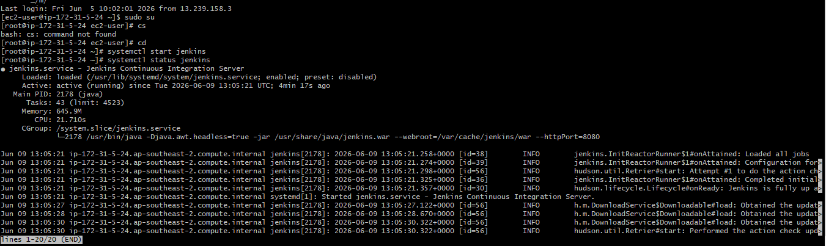
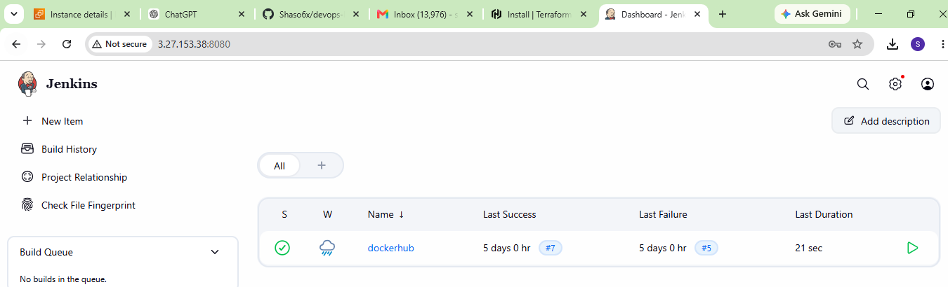

created a new item with simple-tf:
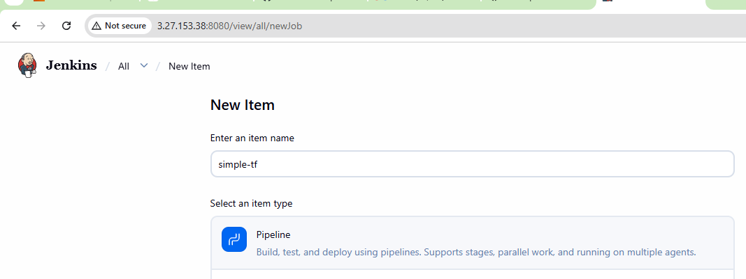
follow the below command in the git bash and then run the script in Jenkins:
sudo yum install -y yum-utils
sudo yum-config-manager --add-repo https://rpm.releases.hashicorp.com/AmazonLinux/hashicorp.repo
sudo yum -y install terraform
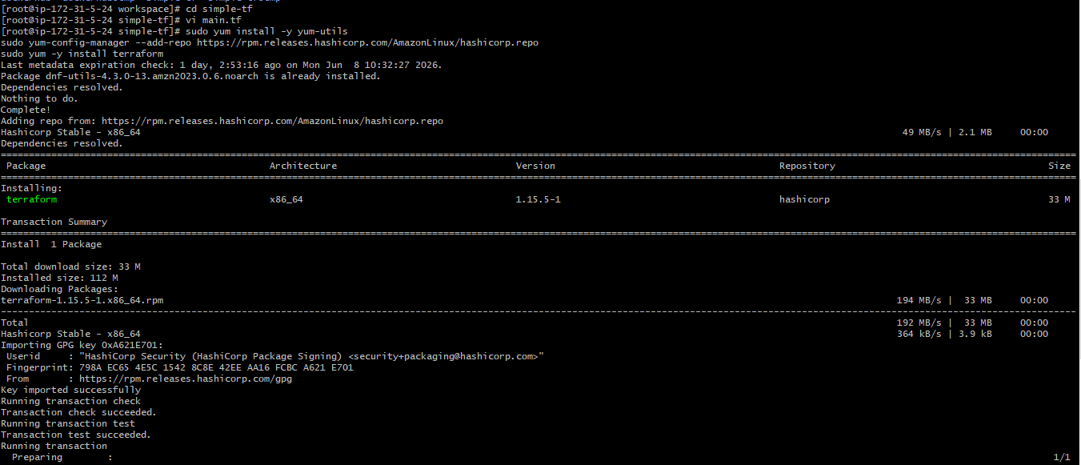
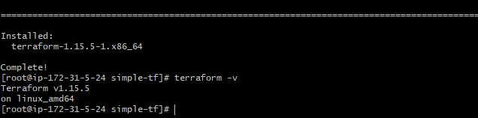
pipeline {
agent any

stages {

stage('Check Workspace') {
steps {
sh '''
echo "Current directory:"
pwd
ls -la
'''
}
}

stage('Terraform Init') {
steps {
sh 'terraform init'
}
}

stage('Terraform Plan') {
steps {
sh 'terraform plan'
}
}

stage('Terraform Apply') {
steps {
sh 'terraform apply -auto-approve'
}
}
}
}
Add this above script in the pipeline and then checked with the console output:
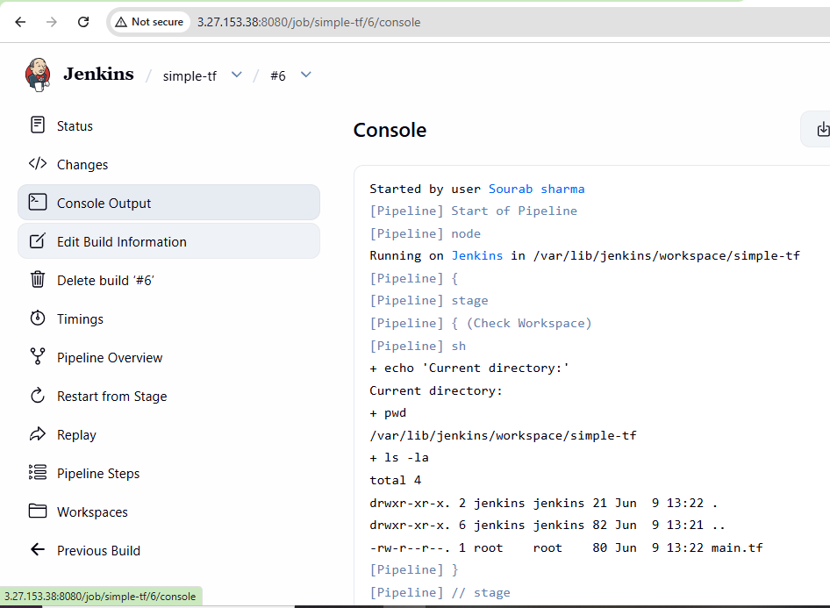
checked the output which is successful:
